Graphs
Experiment # 1
SIG NAL GENERATOR AND OSCILLOSCOPE
1. Use the signal generator and the oscilloscope to perform the following tasks. 2, Build circuit shown below in Figure I
3m Set the signal generator to generate a sinusoidål signal with a frequency of 100 1-Iz and peak-ti peak voltage of 5V.
4. Set up one probe across input signål, and another across RI and R2 alternatively.
5+ Measure and draw all the voltages and time related parameters on the graphs below.
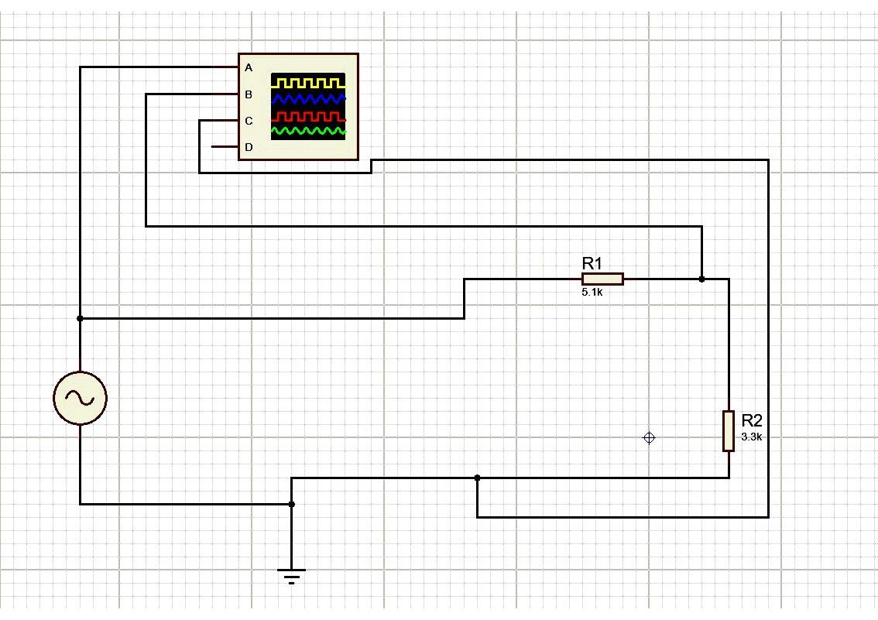
21
Experiment # 2
SIGNAL GENERATOR AND OSCILLOSCOPE
I . Use the signal generator and the oscilloscope to perform the following tasks.
- Build circuit 'B' shown below in Figure 7.
- Set the signal generator to generate a sinusoidal signal with a frequency of 200 HI and peak-to peak voltage of 7 V.
- Set up one probe across input signal, and another across RI, R2 and R3 alternatively,
- Measure and draw all the voltages and time related parameters on the graphs below
